**Domain Background:**

Accurate identification of plant species is essential for a wide range of use cases starting from biodiversity and conservation project, agriculture project and simple nature explorations among others. So far, this task required a specialist knowledge, was time consuming and was often difficult even for professionals. The image classification algorithms are considered to be as a promising directions in reducing the complexity in plan species classification and assisting the professionals whenever possible. Before the deep learning methods became available, the task was primarily tackled by identifying the leaf shape patterns, however this required a clear picture of a leave against a white background and had limited accuracy. Deep learning methods allow to use “noisy” photo images and provide increased accuracy.

A range of academic studies has been conducted in the field [1],[2]

There exist a number of mobile apps that aim to tackle the problem:  noticeable progress in this way was achieved by several projects and apps like LeafSnap (<http://leafsnap.com/>), PlantNet (<http://identify.plantnet-project.org/>) or Folia (<http://liris.univ-lyon2.fr/reves/content/en/index.php>).

In addition, the CLEF evaluation forum (<http://www.imageclef.org/>) hosted a number of challenges over the last few years aiming to increase the accuracy of the identification, which is the main source of both the dataset and an inspiration for the project in general (<http://www.imageclef.org/lifeclef/2015/plant>)

**Problem Statement:**

In this project, I will use the [Pl@ntView](mailto:Pl@ntView) dataset as provided by the Live CLEF challenge from 2015 to identify the plant species, based on available photos. This is a multi-class classification problem, where the goal is to retrieve the correct plant species among the top results of a ranked list of species returned by the evaluating system. Queries are not defined as single images but as **plant observations**, meaning a set of 1 to 5 images depicting the same individual plant observed by the same person the same day. Each image of a query observation is associated with a single view type (entire plant, branch, leaf, fruit, flower, stem or leaf scan) and with contextual meta-data (data, location, author).

**Datasets and inputs:**

I will be using the [Pl@ntView](mailto:Pl@ntView) dataset which has data on 1 000 herb, tree and fern species observed in France. It contains 113,205 pictures belonging each to one of the 7 types of view reported into the meta-data (see figure 1 for an example), in an xml file (one per image) with explicit tags.

Each image is associated with the following meta-data:  
- **ObservationId**: the plant observation ID from which several pictures can be associated  
- **FileName**  
- **MediaId**  
- View **Content**: Branch, Entire, Flower, Fruit, Leaf, LeafScan, Stem  
- **ClassId**: the class number ID that must be used as ground-truth. It is a numerical taxonomical number used by Tela Botanica  
- **Species** the species names (containing 3 parts: the Genus name, the Species name, the author(s) who discovered or revised the name of the species)  
- **Genus**: the name of the Genus, one level above the Species in the taxonomical hierarchy used by Tela Botanica  
- **Family**: the name of the Family, two levels above the Species in the taxonomical hierarchy used by Tela Botanica  
- **Date**: (if available) the date when the plant was observed,  
- **Vote**: the (round up) average of the user ratings on image quality  
- **Locality**: (if available) locality name, most of the time a town  
- **Latitude & Longitude**: (if available) the GPS coordinates of the observation in the EXIF metadata, or, if no GPS information were found in the EXIF, the GPS coordinates of the locality where the plant was observed (only for the towns of metropolitan France)  
- **Author**: name of the author of the picture,  
And if the image was included in previous plant task:  
- **Year**: ImageCLEF2011, ImageCLEF2012, ImageCLEF2013, PlantCLEF2014 when the image was integrated in the benchmark  
- **IndividualPlantId2013**: the plant observation ID used last year during the ImageCLEF2013 plant task,  
- **ImageID2013**: the image id.jpg used in 2013.

Each image has 2 files: the picture and its associated xml file:  
- [6.jpg](http://www.imageclef.org/system/files/6.jpg)  
- [6.xml](http://www.imageclef.org/system/files/6.txt)

Images of a various sizes, so need to be normalized.

Partial meta-data information can be found in the image's EXIF, and might include:  
- the camera or the scanner model,  
- the image resolutions and the dimensions,  
- for photos, the optical parameters, the white balance, the light measures…

The training data contains 27,907 plant-observations illustrated by 91,759 images (8130 of "Branch", 16235 photographs of "Entire", 28225 of Flower", 7720 "Fruit", 13367 of "Leaf", 5476 "Stem" and 12605 scans and scan-like pictures of leaf) with complete xml files associated to them.

The test data results in 13,887 plant-observation-queries illustrated by 21,446 images (2088 of "Branch", 6113 photographs of "Entire", 8327 of Flower", 1423 of "Fruit", 2690 of "Leaf", 584 "Stem" and 221 scans and scan-like pictures of leaf) with purged xml files, i.e without the taxon name (the ground truth), the vernacular name (common name of the plant) and the image quality ratings (that would not be available at query stage in a real-world mobile application).

Test data is available here:

[*http://otmedia.lirmm.fr/LifeCLEF/PlantCLEF2015/Packages/TrainingPackage/...*](http://otmedia.lirmm.fr/LifeCLEF/PlantCLEF2015/Packages/TrainingPackage/PlantCLEF2015TrainingData.tar.gz)

Train data is available here:

[*http://otmedia.lirmm.fr/LifeCLEF/PlantCLEF2015/Packages/TestPackage/Plan...*](http://otmedia.lirmm.fr/LifeCLEF/PlantCLEF2015/Packages/TestPackage/PlantCLEF2015TestDataWithAnnotations.tar.gz)

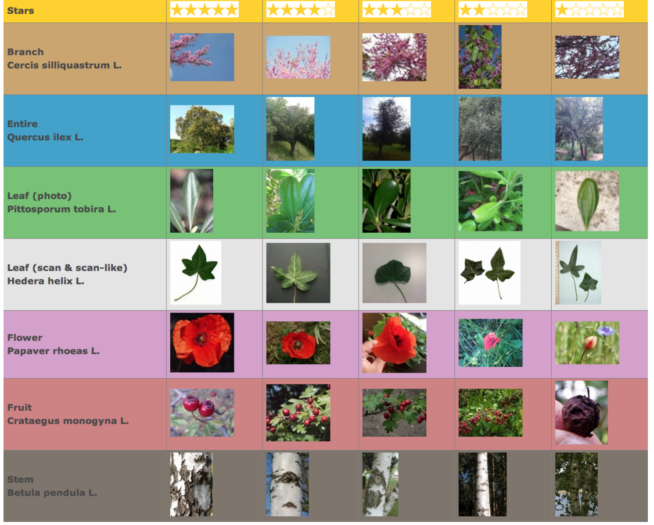

*Figure 1 – dataset illustratation.*

**Solution Statement:**

The goal is to create an evaluation system that will return a rank list of species by probability (based on the available photos).

I will use 2 types of inputs for this project – images and metadata. Images will be normalised and used as an input to the convolutional network. The flat layer (output of the neural network) will be combined with additional input information (metadata). More specifically, I will use **Content metadata** (is the image a stem, fruit, flower etc) as well as a Date field in the metadata (grouped into months) to provide some seasonal information. I will also consider using a geographical location, but this might be highly unbalanced leading to possible over fit.

Each of those flat layers combined with metadata will be fed into a simple classificator (like softmax) to provide a multiclass predictions.

Some plats will have just 1 image of particular kind (for example a flower) – other will have 5 all types of images – in those cases outputs of the softmax layers for each picture will be combined and normalized to provide a final classification.

**Benchmark Model**

A range of modelling approaches (brief descriptions) as well as corresponding classification scores are available here: <http://ceur-ws.org/Vol-1391/157-CR.pdf>

The best model achieved the classification score of ~0.65.

**Evaluation Metrics**

The main metric is the average classification score - a score relates to the rank of the correct species in the list of retrieved species. Each plant observation test will be attributed with a score between 0 and 1: of 1 if the 1st returned species is correct and will decrease quickly while the rank of the correct species increases. However, because of the way the data was collected, we need to account for possible bias due to misbalance between number of submissions for an individual plant - some collaborators provided much more observations compared to an average submission. Therefore, a per/collaborator score is more appropriate:

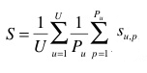

Here S is the classification score, U – number of users (who have at least one image in the test data); Pu - Pu : number of individual plants observed by the u-th user; Su,p : score between 1 and 0 equals to the inverse of the rank of the correct species (for the p-th plant observed by the u-th user);

**Project Design**

The dataset will be normalised to a uniform size. This will be followed by a dataset augmentation – images will be rotated around the centre by +/- 20 degrees to account for real conditions when photos are not always vertical. In addition, left/ right image flipping as well as random clipping will be used.

The colour of the images likely will be maintained, although I will also explore using just black and white images. While the approach might change during the course of the project, I intent to use a pre-trained CNN architecture (like ImageNet) a tuning process will be conducted to the train the last layer. Due to time and complexity considerations, I will use just 1 CNN to classify all image types – an aggregation method, such as softmax or sum pooling will be used to determine the actual species.

Reference:

1. Kumar, N., Belhumeur, P.N., Biswas, A., Jacobs, D.W., Kress, W.J., Lopez, I.C., Soares, J.V.B.: Leafsnap: A computer vision system for automatic plant species identification. In: European Conference on Computer Vision. pp. 502–516 (2012)
2. Joly, A., Go¨eau, H., Bonnet, P., Baki´c, V., Barbe, J., Selmi, S., Yahiaoui, I., Carr´e, J., Mouysset, E., Molino, J.F., et al.: Interactive plant identification based on social image data. Ecological Informatics 23, 22–34 (2014)